DRIVER UPDATE MANUAL
Introduction: The following manual describes how to manually update the XIMEA USB driver.
Windows security update from April 2026 enforces stricter driver signature validation, which may block older USB drivers. This is due to operating system security changes and does not indicate any issue with XIMEA hardware or software. The update is being rolled out gradually across Windows 11 systems.
Ximea provides driver version 2.0.9, which is also accepted by the new security policy; however, it is not yet officially distributed in the software package.
How to update driver manualy:
Download driver version 2.0.9 from XIMEA and extract it into an accessible folder.
Connect the XIMEA USB camera to the PC. Open Device Manager (right-click the Windows icon in the Start menu and select Device Manager), then expand Imaging devices, right-click XIMEA USB3…, and select Update driver.
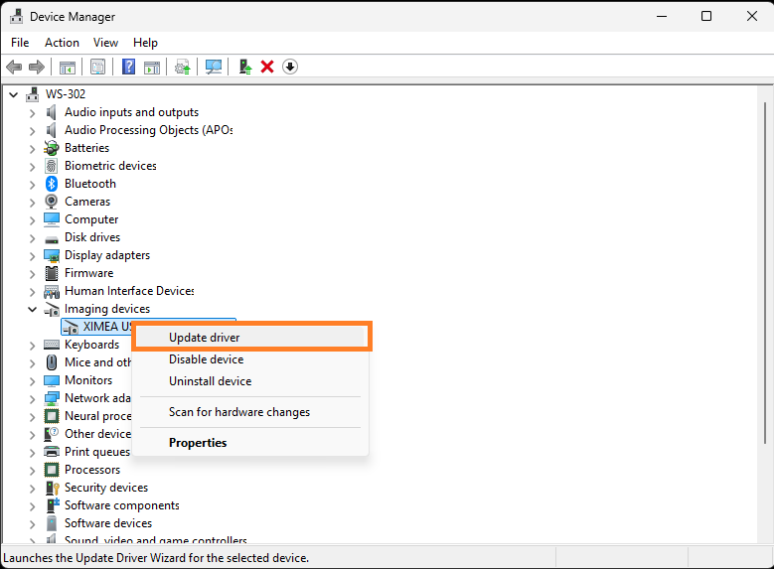

Select Browse my computer for drivers.
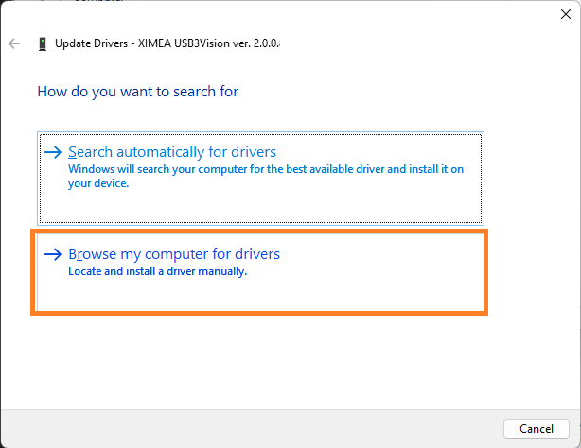

Select Browse …
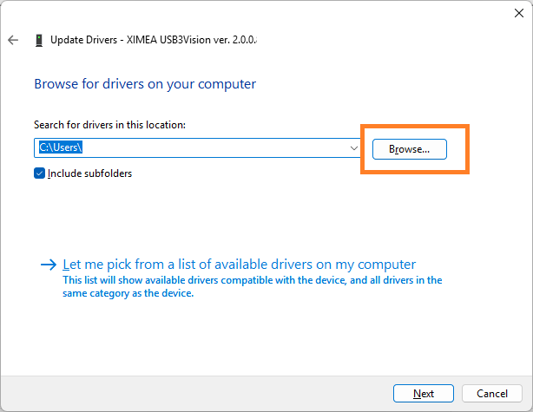

Select the folder where you extracted the downloaded driver version 2.0.9., and press OK to continue.
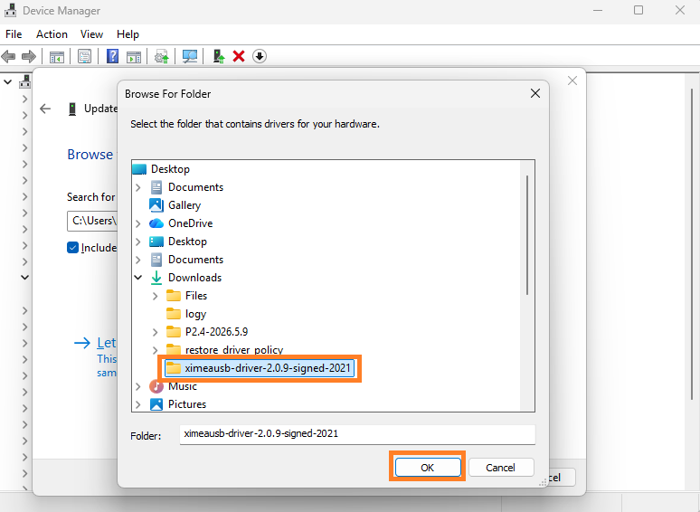

Press NEXT to continue.
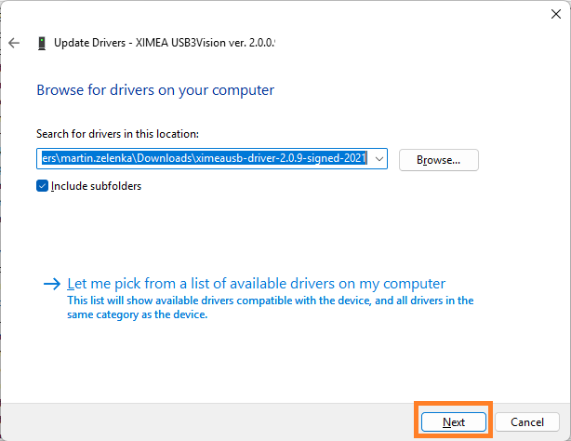

If everything completes successfully, you should see the following window.
